**ANGULAR COMPONENTS**

## **What Are Angular Components?**

Components are the building blocks of a UI in an Angular application. These components are associated with a template and are a subset of directives.

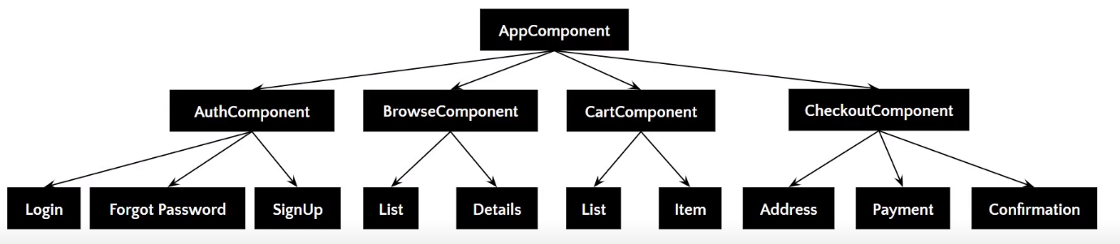

The above image gives the tree structure of classification. There’s a root component, which is the AppComponent, that then branches out into other components creating a hierarchy.

Here are some of the features of Angular Component:

* Components are typically custom [HTML](https://www.simplilearn.com/tutorials/html-tutorial/what-is-html) elements, and each of these elements can instantiate only one component.
* A TypeScript class is used to create a component. This class is then decorated with the “@Component” decorator.
* The decorator accepts a metadata object that gives information about the component.
* A component must belong to the NgModule in order for it to be usable by another component or application.
* Components control their runtime behavior by implementing Life-Cycle hooks.

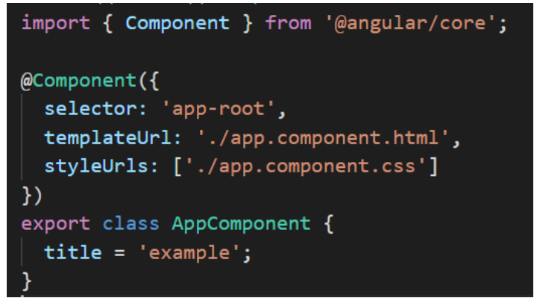

The above image shows an App component, which is a pure TypeScript class decorated with the “@Component” decorator. The metadata object provides properties like selector, templateUrl, and so on—the templateUrL points to an HTML file that defines what you see on your application.

In the index.html file, <app-root> tag corresponds to component’s selector. By doing so, Angular will inject the corresponding template of the component.

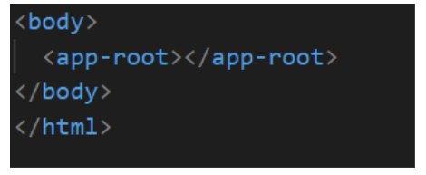

## **Creating Your First Angular Component**

* To create an Angular Component, Angular CLI is used. In the terminal, type in the command,

  ng g c component-name

## **Component Decorator Metadata**

As mentioned earlier, the @Component decorator accepts a metadata object that provides information about the component. Here’s a list of properties of the metadata object:

### **Selector**

It is the CSS selector that identifies this component in a template. This corresponds to the HTML tag that is included in the parent component. You can create your own [HTML tag](https://www.simplilearn.com/tutorials/html-tutorial/html-tags). However, the same has to be included in the parent component.

### **Template**

It is an inline-defined template for the view. The template can be used to define some markup. The markup could typically include some headings or paragraphs that are displayed on the UI.

### **TemplateUrl**

It is the URL for the external file containing the template for the view.

### **Styles**

These are inline-defined styles to be applied to the component’s view

### **styleUrls**

List of URLs to stylesheets to be applied to the component’s view.

### **Providers**

It is an array where certain services can be registered for the component

### **Animations**

Animations can be listed for the components

## **Demo: Creating an Angular Component**

